Name________________________________ Easy/Medium-level Practice questions

Homework Questions: You must show all work in order to get full credit

1)
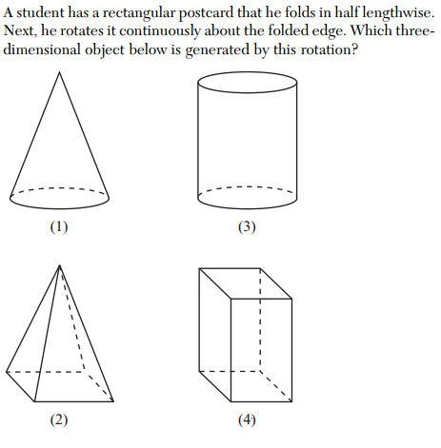
2)
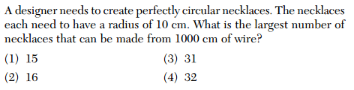

3)
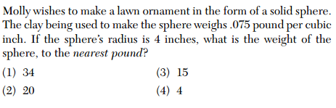
4)
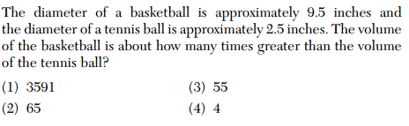

5)
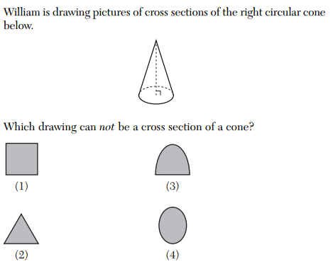

6)
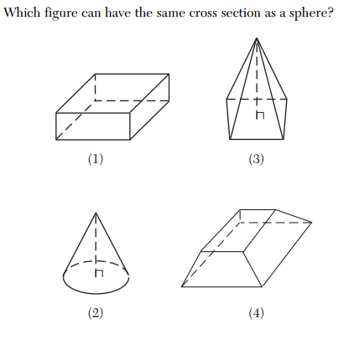
7)
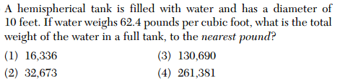

8)
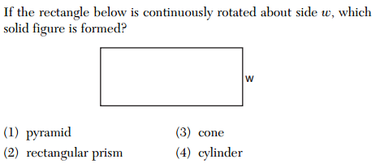

9)
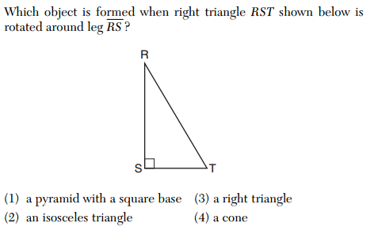
10) (this is an Area question on the Regents…. not a volume question)
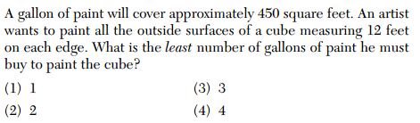
11)
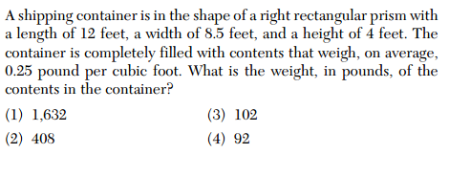

12)
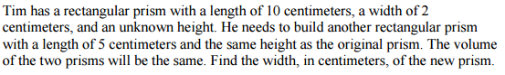

13)
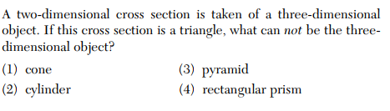
14)
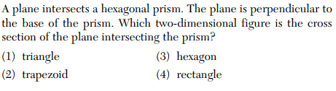
15)
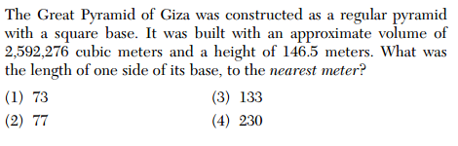

16) A paint can is in the shape of a right circular cylinder. The volume of the paint can is 600 cubic inches and its altitude is 12 inches.
Find the radius, in inches, of the base of the paint can. Express the answer in simplest radical form.

17)
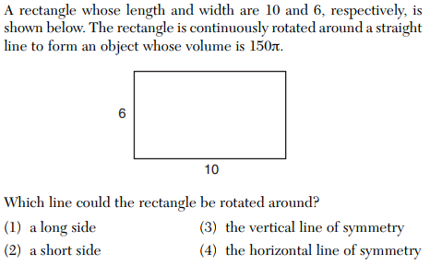
18)
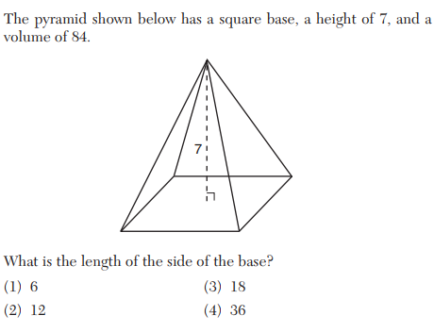

19)
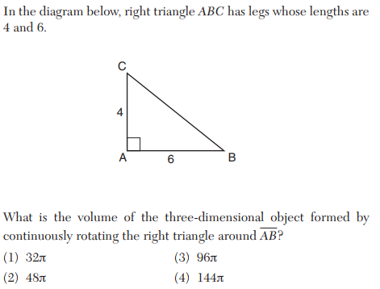

20)
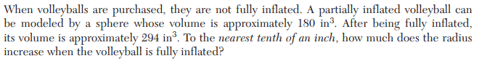

21)
